Jialiang Zhou

Stephanie Sharp

Alexander Cannell

Jojo Joseph

Craig Randall

2/24/2012

Professor Robertson

Chapter 7

Project 7-1:

Well Wilke’s environmental group will need to use either of two WAN topologies Mesh or SONET ring. We recommend she should use a SONET ring topology, and this topology will work for our office to office connection. We would recommend that she should use a VPN and ICA, we would also like to recommend VPN because doesn’t require expensive software, and this will be for our mobile to office. For their home to office solution we could use VPN and ICA, but VPN would work best through dial up connections.

Project 7-2:

Being concerned about network security is important for a business and we would recommend that she should use VPN that uses protocols that includes tunneling protocol L2TP has more security.

Project 7-3:

Office to Mobile 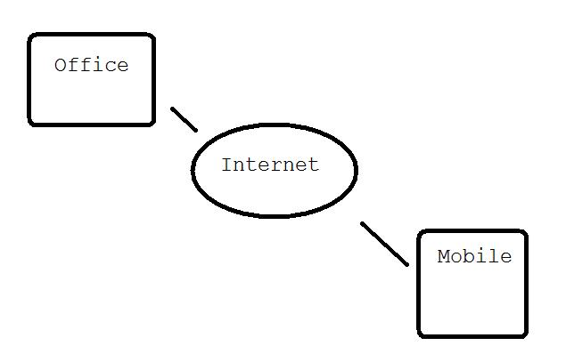

Office to Home with T-Carriers:

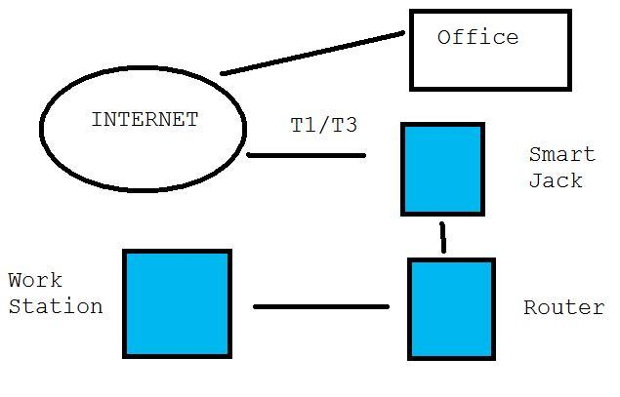

SONET Ring Topology Office to Office:

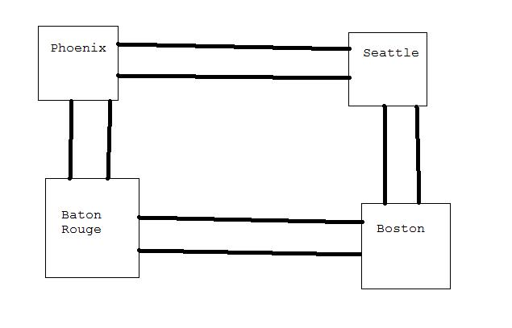

The Hardware that you will like to use is VPN Routers, SONET/T-Carrier’s internet, common cables, servers and etc…